**Sprint 4 Plan**Product Name: Canvas To Calendar

Team Name: Kirb Squad

Sprint Completion Date: 06/06/2023

Revision Number: 0

Revision Date: N/A

**High Level Goals**

* **Goal**

As this is our last Sprint for the class, we want to focus on refining our MVP so that it works with no problems and pick up on some other functionality from the backlog to implement. Also based on feedback from others, we have decided to migrate to the Google Task API as this makes more sense for things like assignments.

* **List of User Stories**

As a student, I want to be able to easily create unique tasks in my Google Calendar via Canvas To Calendar extension. [4.1]

**Task 1**: Create UI that will allow users to create a task name with other fields that are desired to be put in the calendar.

(~6 hours)

**Task 2:** Integrate Google’s Task API with user created tasks to put into the user’s Calendar.

(~2 hours)

As a student, I want to be able to select assignments to add from my classes into my calendar via a dropdown menu on the extension. [4.2]

**Task 1**: Create a dropdown menu with selectable assignments from the canvas API.

(~4 hours)

As a student, I want Canvas To Calendar to mark tasks past due date as completed, but not duplicate any tasks. This will be easier to manage in my calendar. [4.3]

**Task 1**: Look into Javascript’s libraries to find something that can get the current user’s date/time to compare to the assignment’s due date.

(1 hour)

**Task 2**: Implement this in the insertion functionality to see when to mark tasks as completed before inserting.

(1 hour)

**Task 3**: Use Google’s Task API to retrieve what task/list the user currently has.

(~2 hours)

**Task 4**: Compare the user’s retrieved data to the data to be injected and skip over any duplicates.

(~3 hours)

**Team Roles**

**Myles Marr**: Product Owner, Developer

**Lucas Michellys**: Developer

**Kaled Barraj**: Developer

**Utkarsh Pandey**: Developer

**Johan Suresh**: Scrum master, Developer

**Initial Setup**

* **Task Assignment**

**Myles Marr**: [4.2], Task 1

**Lucas Michellys**: [4.1],Task 1

**Kaled Barraj**: [4.1], Task 2, [4.3], Task 1 & 2

**Utkarsh Pandey**: [4.2], Task 1

**Johan Suresh**: [4.3], Task 3 & 4

* **Burnup Chart**

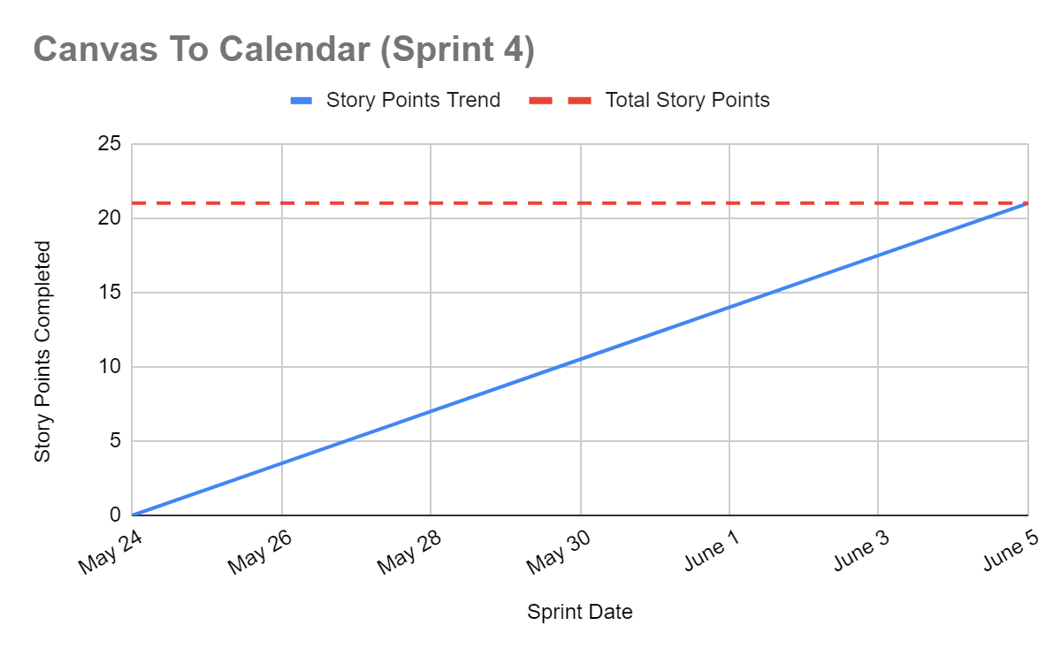

* **Scrum Board**

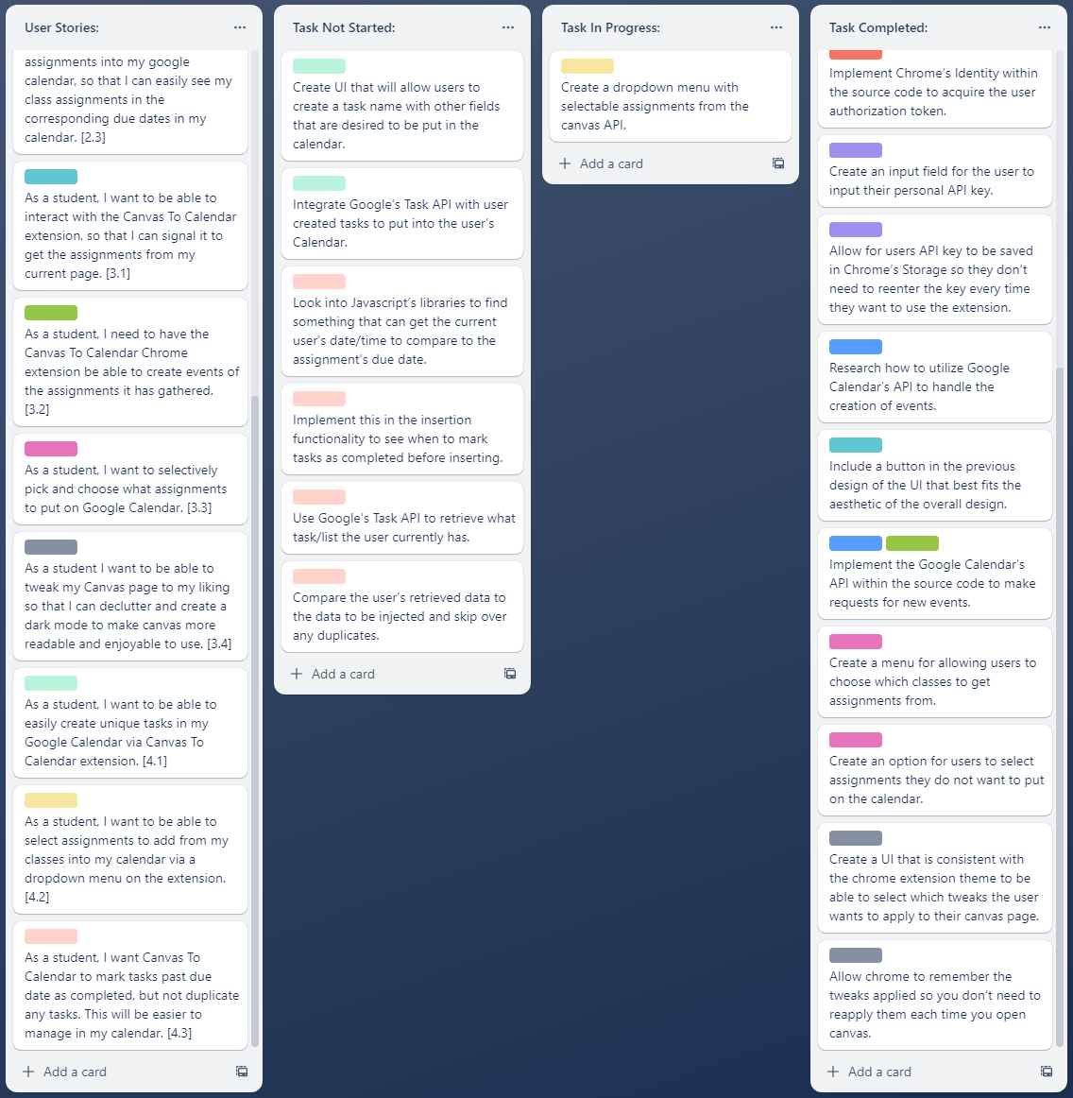

**Scrum Meeting Times**

**Monday:** In the Engineering 1, (9:15 am - 10:15 am)

**Wednesday:** After Zoom with TA, (4:50 pm - 5:20 pm)

**Friday**: Over Discord, (5:00 pm - 5:30 pm)